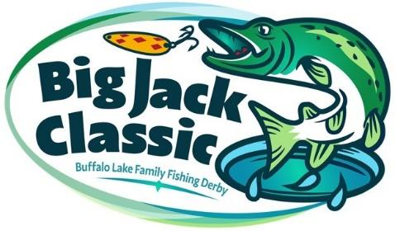 2026 Participant Waiver Form
In consideration of being permitted to participate in any way in the Buffalo Lake Big Jack Classic Association’s (hereby referred to as “BLBJCA”) Big Jack Classic Family Ice Fishing Derby (hereby referred to as “Big Jack Classic”), related events and activities, the undersigned acknowledges, appreciates, and agrees that:

- I hereby freely accept all the risks (known and unknown) however caused associated with participating in the derby, whether the risks result in personal injury, property damage or some other harm to me.

- I willingly agree to comply with the stated and customary terms and conditions for participation, and I grant permission to be photographed or videoed during the event for the promotion of the Big Jack Classic in future years.

- If I observe any unusual or significant hazard during my presence or participation, I will remove myself from participation and bring such to the attention of the nearest official immediately.

- As a condition of the BLBJCA allowing me to participate in the Big Jack Classic, I (for myself and on behalf of my heirs, next of kin, and personal representatives) agree to waive all claims that I have or may have in the future against the BLNJCA its officers, officials, agents and/or employees, committee members, volunteers, other participants, and sponsoring agencies/advertisers for any injury, property damage, financial loss, or any other loss that may result directly or indirectly from my participation in the Big Jack Classic, no matter how this loss is caused (including negligence on the part of the organizing committee).

I HAVE READ THIS RELEASE OF LIABILITY AND ASSUMPTION OF RISK AGREEMENT AND FULLY UNDERSTAND ITS TERMS, UNDERSTAND THAT I HAVE GIVEN UP SUBSTANTIAL RIGHTS BY SIGNING IT, AND SIGN IT FREELY AND VOLUNTARILY WITHOUT ANY INDUCEMENT.
Printed Name of Participant:
Signature of Participant: | Date:
Signature of Witness: | Date:

If under the age of 18 at the time of registration:
This is to certify that I, as a parent/guardian with legal responsibility for this participant, do consent and agree to his/her release as provided above for all the Releasees, and for myself, my heirs, assigns, next of kin, I release and agree to indemnify the Releasees from any and all liabilities incident to my minor child’s involvement or participation in these programs as provided above.
Printed Name of Minor Participant:
Printed Name of Parent or Guardian:
Emergency Phone Number (s):
Signature of Parent/ Guardian: | Date:
Signature of Witness: | Date:

